Acceptance Testing
UAT Execution & Report Submission

Date | 25 June 2026
Team ID
Project Name | An employee requests installation of licensed software through the Service Catalog
Maximum Marks | 4 Marks

1. Purpose of Document
The purpose of this document is to briefly explain the test coverage and open issues of the Software Installation Request System project at the time of the release to User Acceptance Testing (UAT).
2. Defect Analysis
This report shows the number of resolved or closed bugs at each severity level, and how they were resolved.
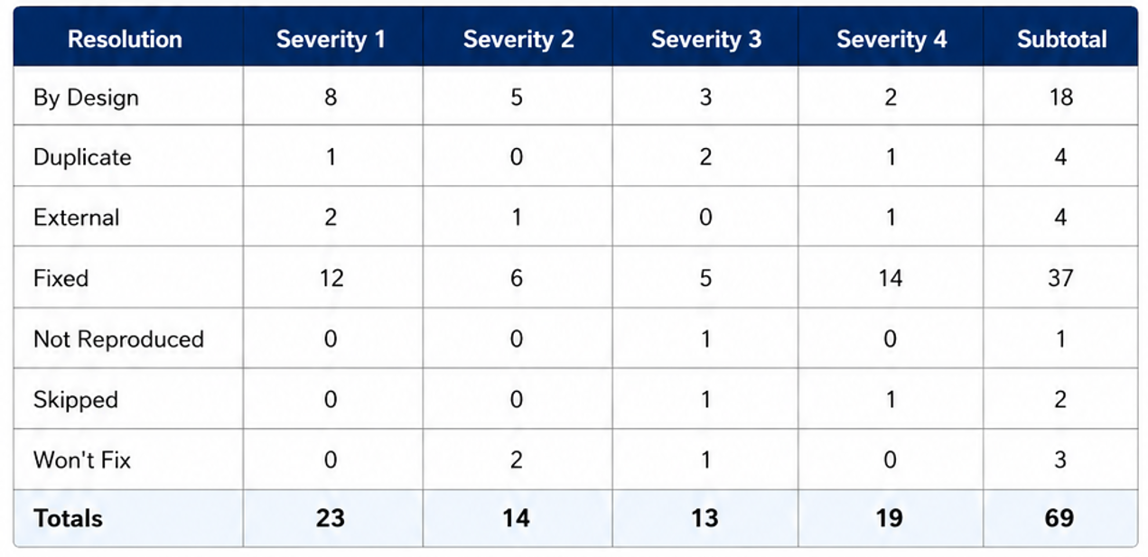

3. Test Case Analysis
This report shows the number of test cases that have passed, failed, and untested.
